|  |  |  |
| --- | --- | --- |
| **Academic Year:** 2024-25 | **Year:** Second Year | **Semester:** II |
| **PRN No.:** | **Name:** | |
| **Subject:** Database Management System | | |
| **Assignment No.**: 2 |  | |
| **Date:** |  | |

**Lab Assignment: 02**

**Title: DDL Queries**: Design and develop SQL DDL (Data Definition Language) statements to demonstrate the creation and management of various SQL objects like Creating tables with appropriate data types and constraints such as PRIMARY KEY, FOREIGN KEY, UNIQUE, NOT NULL, DEFAULT and CHECK.

1. Defining indexes to optimize query performance on large datasets.
2. Use auto_increment to generate unique numeric values for a primary key column.

**Theory:**

**What is SQL?**

SQL (Structured Query Language) is a language used to manage and manipulate relational databases. It allows users to create, retrieve, update, and delete data efficiently. SQL is used in databases like MySQL, PostgreSQL, SQL Server, and Oracle.

Types of SQL Commands:

* DDL (Data Definition Language) – Defines database structures (e.g., CREATE, ALTER, DROP).
* DML (Data Manipulation Language) – Modifies data (e.g., INSERT, UPDATE, DELETE).
* DCL (Data Control Language) – Manages permissions (e.g., GRANT, REVOKE).
* TCL (Transaction Control Language) – Controls transactions (e.g., COMMIT, ROLLBACK).

**What is DDL?**

DDL (Data Definition Language) is a category of SQL commands used to define, modify, and manage the structure of database objects such as tables, indexes, and schemas.

DDL Commands:

1. CREATE – Creates a new database, table, or index.

CREATE TABLE Students (

id SERIAL PRIMARY KEY,

name VARCHAR(100),

age INT

);

1. ALTER – Modifies an existing table (e.g., add/drop a column).

ALTER TABLE Students ADD COLUMN email VARCHAR(100);

1. DROP – Deletes an entire database or table.

DROP TABLE Students;

1. TRUNCATE – Removes all records from a table but keeps its structure.

TRUNCATE TABLE Students;

**Database Keys and their explanation**

Keys in a database help in uniquely identifying records in a table.

Types of Database Keys:

1. Primary Key – Uniquely identifies each record in a table.

CREATE TABLE Employees (

emp_id SERIAL PRIMARY KEY,

emp_name VARCHAR(100)

);

1. Foreign Key – Establishes a relationship between two tables.

CREATE TABLE Orders (

order_id SERIAL PRIMARY KEY,

emp_id INT,

FOREIGN KEY (emp_id) REFERENCES Employees(emp_id)

);

1. Unique Key – Ensures unique values in a column but allows NULL values.

CREATE TABLE Users (

user_id SERIAL PRIMARY KEY,

email VARCHAR(100) UNIQUE

);

1. Candidate Key – A set of attributes that could be a primary key.
2. Super Key – A combination of attributes that uniquely identifies a record.
3. Composite Key – A primary key consisting of multiple columns.

CREATE TABLE Enrollments (

student_id INT,

course_id INT,

PRIMARY KEY (student_id, course_id)

);

**Constraints and Types**

**Constraints are rules applied to database columns to maintain data integrity.**

**Types of Constraints:**

1. NOT NULL – Prevents a column from storing NULL values.

CREATE TABLE Employees (

emp_id SERIAL PRIMARY KEY,

emp_name VARCHAR(100) NOT NULL

);

1. UNIQUE – Ensures all values in a column are unique.

CREATE TABLE Users (

user_id SERIAL PRIMARY KEY,

email VARCHAR(100) UNIQUE

);

1. PRIMARY KEY – Ensures uniqueness and NOT NULL constraint.
2. FOREIGN KEY – Establishes a relationship between tables.
3. CHECK – Ensures a column meets specific conditions.

CREATE TABLE Products (

product_id SERIAL PRIMARY KEY,

price DECIMAL(10,2) CHECK (price > 0)

);

1. DEFAULT – Assigns a default value if no value is provided.

CREATE TABLE Employees (

emp_id SERIAL PRIMARY KEY,

department VARCHAR(50) DEFAULT 'HR'

);

**Auto Increment**

Auto-increment is used to automatically generate unique values for a column.

**Show Query Execution Screenshots for:**

* Database Creation
* Show database list
* Table Creation with Primary, Foreign and Unique Key
* Table Creation with use of Constraints – Not Null, Check, Default
* Show Table List
* Display Table Structure
* Foreign Key with On Delete cascade and On update no action
* Auto Increment
* Auto Increment with Alter to set new Initial Value
* **Alter Table:**

1. Add New Attribute at second position
2. Drop existing attribute
3. Change data type of any attribute
4. Change attribute name
5. Change Table Name

* Show Comments
* Create and drop Index
* Truncate Table
* Drop table
* Drop Database

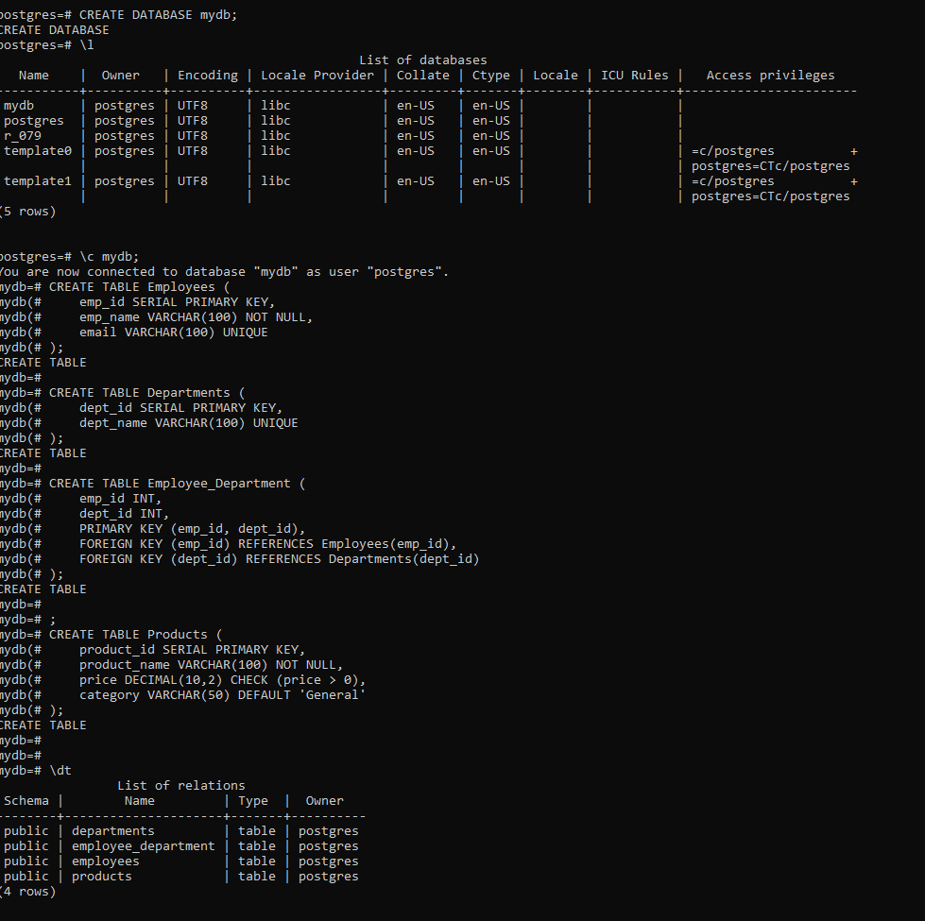

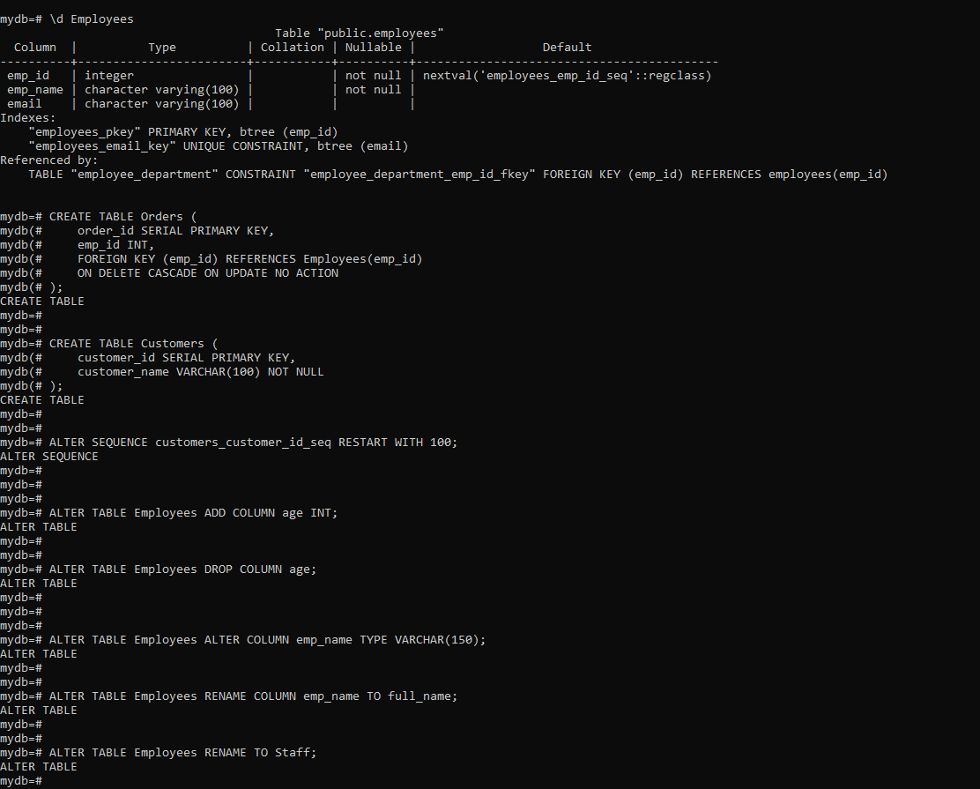

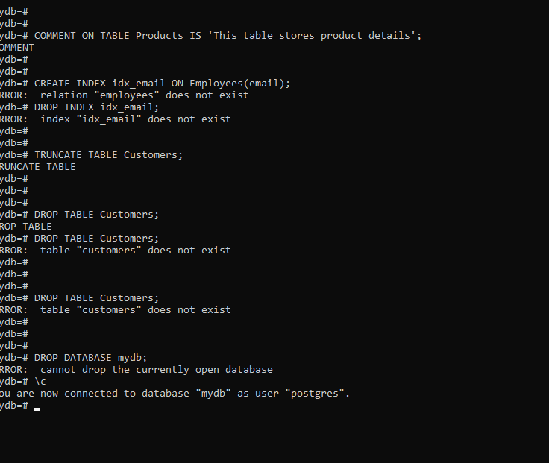

**Conclusion:**

**FAQs:**

1. Which version of MYSQL have you installed?

**MySQL 8.0**

1. Explain MySQL Client - server architecture.

MySQL follows a **Client-Server Architecture**, where:

* The **MySQL Server** manages the database, processes queries, and handles transactions.
* **Clients** (like MySQL Workbench, Command Line, or Applications) send SQL queries to the server.
* The **server processes** the queries and returns results.
* Communication happens using **TCP/IP** or **Unix sockets**.

1. Find out databases used for following applications.

A. Twitter: MySQL, Manhattan B. Facebook: MySQL, TAO

C. Amazon / Flipkart: DynamoDB, MySQL D. Finacle: Oracle Database

E. LinkedIn: Espresso, MySQL F. PokemonGo: PostgreSQL

G. Panama Papers: Neo4j H. AADHAR Card: MongoDB

1. Categorize following commands under DDL, DML and DCL. Create, Update, Commit, Delete, Drop, Truncate, Rollback, Alter

|  |  |
| --- | --- |
| DDL (Data Definition Language) | CREATE, DROP, ALTER, TRUNCATE |

|  |  |
| --- | --- |
| DML (Data Manipulation Language) | UPDATE, DELETE |

|  |  |
| --- | --- |
| DCL (Data Control Language) | COMMIT, ROLLBACK |

1. Write a DDL statement to remove sales and suppliers database?

DROP DATABASE sales;

DROP DATABASE suppliers;

1. Write the statement that will add a column CGPA to a table Student which is already created

ALTER TABLE Student ADD COLUMN CGPA DECIMAL(3,2);